3 August 2026

Professor Jungho Im
Editor-in-Chief
GIScience & Remote Sensing

Dear Professor Im,

Please consider our manuscript, “Reliability Conditions for Interpreting Daily NASA Black Marble Nighttime Lights in Cloud-Impacted Tropical Regions,” for the Article Collection “Remote Sensing in Cloudy and Rainy Environments: Challenges, Advances, and Applications.”

The manuscript introduces a diagnostic-first framework for determining when daily VIIRS Black Marble observations are sufficiently complete and stable for interpretation in persistently cloudy tropical environments. Using Eastern Visayas as an extreme stress test, the study evaluates observability at pixel and settlement scales and validates reliability-qualified nighttime light trajectories against electricity load across five Visayas sub-grids.

The paper is well aligned with the collection because it addresses a fundamental remote-sensing challenge in cloudy and rainy regions: nominally daily imagery does not necessarily provide daily surface observation. The main contribution is a reproducible procedure for quantifying spatial completeness, temporal completeness, dropout duration, and radiance stability before downstream analysis.

An earlier conference version of this work was published in the ISPRS Archives (10.5194/isprs-archives-XLIX-B2-2026-1091-2026), as part of the recently concluded ISPRS 2026. The present manuscript is substantially expanded through formal metric definitions, long-term and global completeness analysis, systematic threshold evaluation, cross-sub-grid validation, and extensive supplementary diagnostics. The earlier publication is cited and disclosed in the manuscript.

The manuscript is original, is not under consideration elsewhere, and has been approved by all authors. The authors declare no competing interests.

Thank you for considering our submission.

Sincerely,

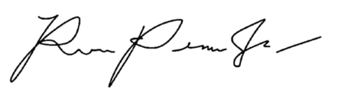

Rene Jr. L. Principe
Corresponding Author
School of Science, RMIT University
s4135723@student.rmit.edu.au

On behalf of Karin Reinke and Simon Jones

